ISMB/ECCB Gala Dinner
Tuesday, 3 August 2004
Tickets Price : £50

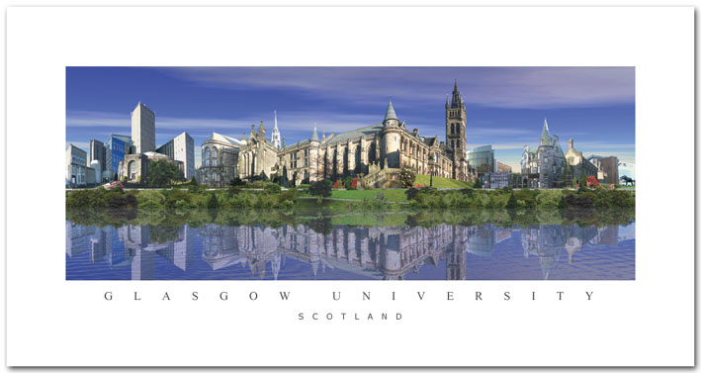

The Gala Dinner will take place in the historic setting of the University of Glasgow

The University of Glasgow was founded in 1451 by Papal Bull and originally classes were held in the Chapter House of Glasgow Cathedral. The University moved into its own buildings in the High Street in the 17th century. The University transferred to its current site on Gilmorehill in the West End of the city in 1870.

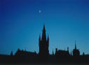

The magnificent Main Building of the University designed in the Gothic style by Sir George Gilbert Scott, is one of the city’s best known landmarks.

Some of the most famous scholars in the world have been associated with the University – James Watt, who developed the steam engine; John Logie Baird, pioneer of television; Lord Kelvin, who became Professor of Natural Philosophy at age 22 and gave his name to a system of measuring temperature; Joseph Lister, pioneer of antiseptic surgery; and Frederick Soddy, who first demonstrated the existence of radioactive isotopes at the University.

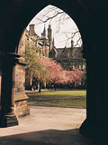

Welcome drinks will take place in the Cloisters with dinner in Hunter’s Halls East & West and Bute Hall. After dinner there will be a chance to experience some Ceilidh dancing, for those who wish. Ceilidh is a Gaelic word meaning ‘an informal gathering for conversation, music, dancing and songs’ in other words ‘a great gala party!’

Ticket price includes transport, welcome drink, dinner, entertainment, and transportation

