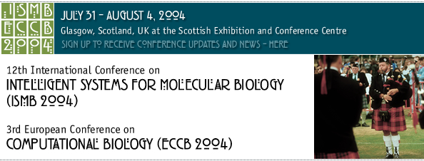

CATERING FOOD & BEVERAGE FORM

URGENT FAX

Whether you’re catering to impress your customers, to keep your exhibition team refreshed, or a little of both, we will be pleased to supply anything from tea and coffee to a full buffet lunch.

We are the exclusive caterer at the Scottish Exhibition + Conference Centre and are committed to providing stand catering to the highest standards of quality and service. We will take your orders for food and drink and deliver it to your stand.

Sandwiches, canapés, snacks, mini pastries, bottles of wine and beer are just some of the items available from our stand order services.

To arrange for a stand catering order form to be sent to you, just complete the attached priority form and fax it to 0141-226-3812.

We would request that stand catering orders are placed well in advance, but no later than 7 working days prior to the event. Early orders will be given priority. Late orders will be subject to availability and there will be no guarantee of delivery time.

Exhibition Name: ISMB/ECCB 2004

Exhibition Date: 31 JULY – 4 AUGUST 2004

Stand No: ………………………………………………………….

Name: ………………………………………………………….

Company: ………………………………………………………….

Address: ………………………………………………………….
………………………………………………………….
………………………………………………………….

Post code: ………………………………………………………….

Telephone: ………………………………………………………….

Fax: ………………. e-mail: ………………………….

FAX TO: 0141-226-3812 or TEL: 0141-576-3141

