Modern Proteomes Contain Imprints of Ancient Shifts in Ocean Chemistry
Christopher L. Dupont¹, Song Yang², Brian Palenik³, Philip E. Bourne⁴
¹Scripps Institution of Oceanography, University of California, San Diego, La Jolla, CA 92093. ²Department of Chemistry and Biochemistry, University of California, San Diego, La Jolla, CA 92093. ³Marine Biology Research Division, Scripps Institution of Oceanography, University of California, San Diego, La Jolla, CA 92093. ⁴Department of Pharmacology and the San Diego Supercomputer Center, University of California, San Diego, La Jolla, CA 92093.

Fe, Zn, Mn, and Co-binding protein fold families (FF) within the proteomes of Archaea, Bacteria, and Eukaryotes are demonstrated to scale to proteome size as a power law with clear stoichiometries. Differences in the power law slopes for each Superkingdom of Life are remarkably consistent with the changes in metal concentrations that occurred with the shift from an anoxic to an oxic ocean, and suggest that Eukaryotes diversified in the latter. Contrasting structural features and functions of the abundant Fe-binding domains further indicate that Prokaryotes and Eukaryotes evolved separately in low and high oxygen environments, respectively. To our knowledge this is the first time that protein structural data has been used to study how environmental pressure shapes evolution.

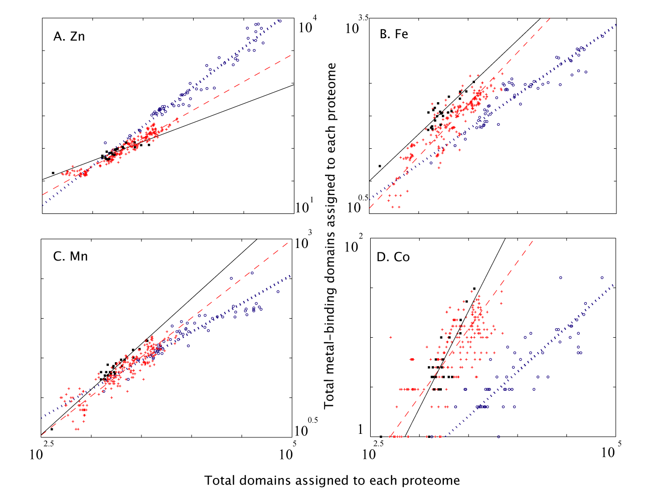
Grand scale perturbations in environmental conditions can be prompted by biology (e.g. the rise in oxygen due to photosynthesis), but shifts in environmental conditions can influence biology in an equally profound fashion, via changes in proteome content. The curves in Fig. 1 show that metal-binding structural domains within a proteome adhere to a simple formula, or stoichiometry (30). Studies of ecological stoichiometry have shown that the concentrations of both major and minor elements within living organisms conform to predictable trends (39, 40), and this study extends these principles to proteomes, completing a circle between the environment, genetic information, and the biochemistry of organisms.

Log-log plots of the abundances of Fe, Zn, Mn, and Co-binding structural domains in proteomes of Archaea (black ■), Bacteria (red *), and Eukaryotes (blue o). Each point represents the number of metal-binding domains and the total number of assigned protein domains in a discrete proteome.

