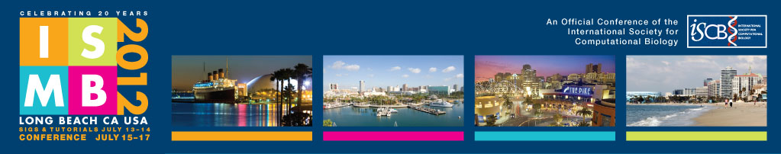

2012 Travel Fellowship Recipient Information
All ISCB travel fellowship recipients are required to complete the form below to receive fellowship funding. PLEASE PRINT CLEARLY
LEGAL NAME: First/Given:_________________________________________________ Last/Family:_________________________________________________________
Complete Name of Institution: _____________________________________________________________________________________________________________________
Who is check made payable to? individual Institution other ___________________________________
Passport Number/Issuing Country:________________________________________________ Date of Birth (mm/dd/yyyy)_______________________________
E-mail Address_______________________________________________________________________ Gender Male Female
Status: Student Post-doc Researcher Faculty other ________________________________________
Presentation Type (check applicable box): Poster Proceedings Paper Highlights Paper Late Breaking Research
Presentation Title____________________________________________________________________________________________________________________________________

Permanent Address
Address (line 1) ______________________________________________________________________________________________________________________________________
Address (line 2) ______________________________________________________________________ City___________________________________________________________
State/Region/Province______________________________________________________________ Country______________________ Zip/Postal code______________
Phone (incl area/intl code) _______________________________________________________________

Current Address (where award check is to be mailed) Check here if same as Permanent Address
Address (line 1) ______________________________________________________________________________________________________________________________________
Address (line 2) ______________________________________________________________________ City___________________________________________________________
State/Region/Province______________________________________________________________ Country______________________ Zip/Postal code______________
Phone (incl area/intl code) _______________________________________________________________
U.S. Residency Status: U.S. Citizen U.S. Permanent Resident Resident Alien Non-resident Alien Other______________
Ethnicity (U.S. Citizens and U.S. Permanent Residents only):
Japanese/Japanese-American African-American Latino/Latino-American
Native American or Alaskan Native Polynesian/Micronesian East Indian/Pakistani
Chicano/Mexican American/Puerto Rican White/Caucasian Philipino/Filipino
Korean/Korean-American Thai/Other Asian Chinese/Chinese-American
Vietnamese Other, please specify__________________________________________
Receipts (tick all applicable boxes and fill in amounts and currency)
Amount (receipt total) Currency (US$ office use only)
Travel ____________________ _______________ _______________
Conference Registration (early registration fee only) ____________________ _______________ _______________
Lodging (max of 780 USD) ____________________ _______________ _______________
Meals (max of 165 USD) – (no receipts required)
Please sign and date the line below.
____________________________________________________________________________________________________________________________________________________________
(Signature) (Date)
Office Use Only: TOT Amount of Check $_______________________ Check # ____________________ Check made out to:__________________________________

